Stephanie Davis

Database: Advanced Level Project: Student Course Enrolment System

Project 3

**Requirements**:

**Database Name**: SchoolDB

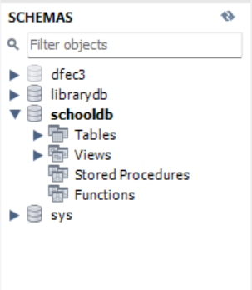

1. **Tables**:

***1.1 Students***: student_id (Primary Key), first_name, last_name, date_of_birth, email

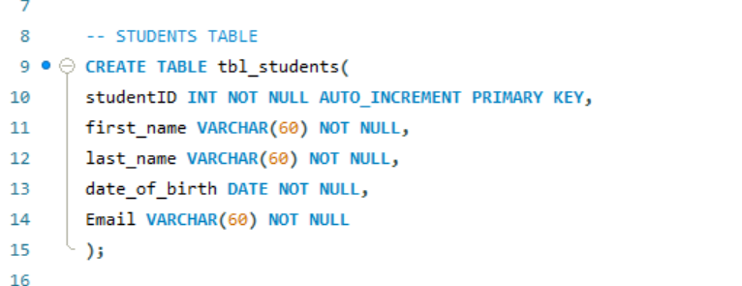

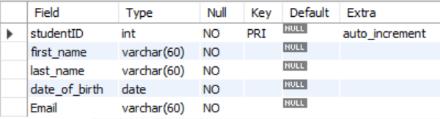

**1.2 Courses**: course_id (Primary Key), course_name, description, credits

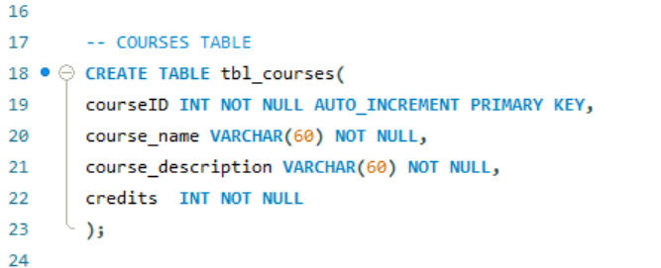

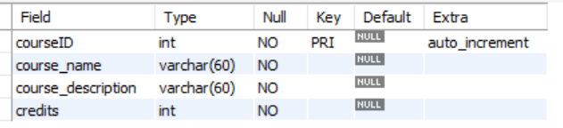

**1.3 Enrolments**: enrollment_id (Primary Key), student_id (Foreign Key referencing , Students.student_id), course_id (Foreign Key referencing Courses.course_id), enrolment_date, grade

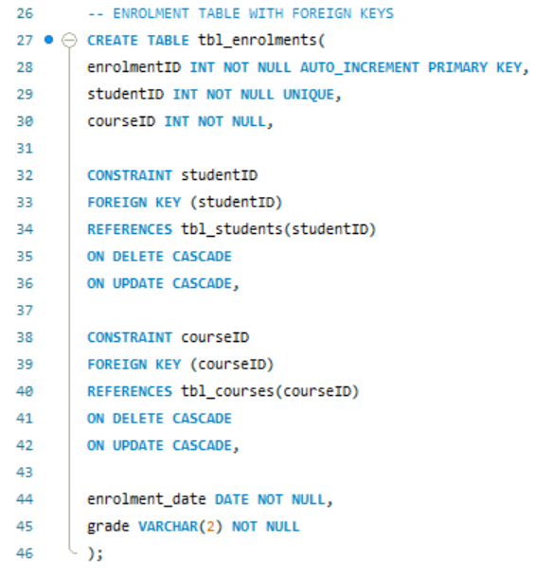

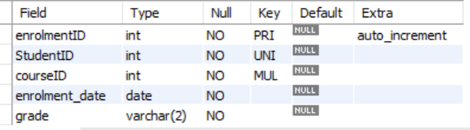

1. **Insert sample data into each table.**

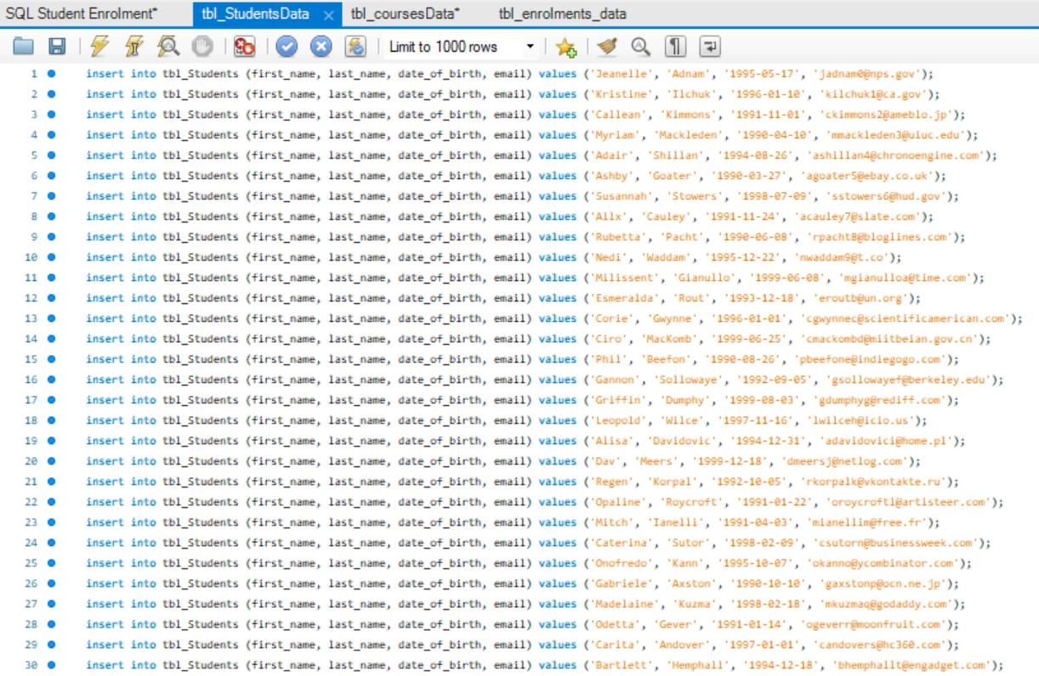2.1 Students table

2.2 Courses table

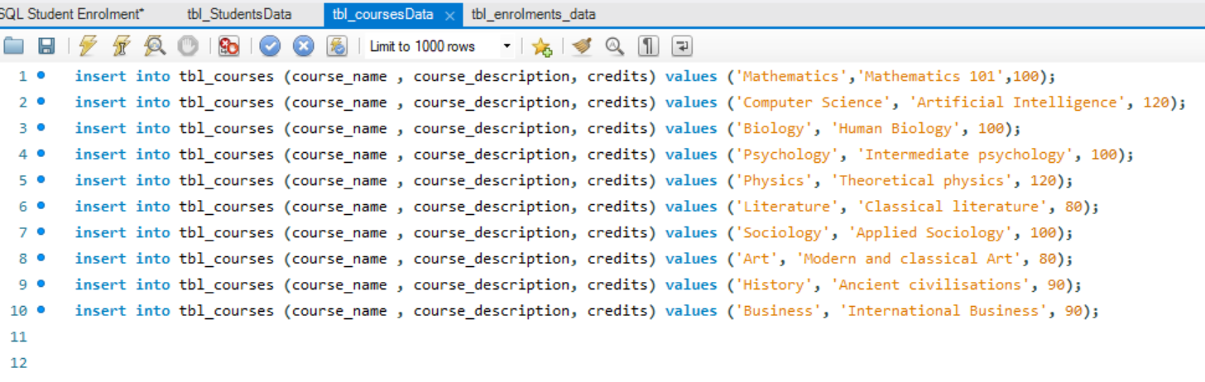

2.3 Enrolment table

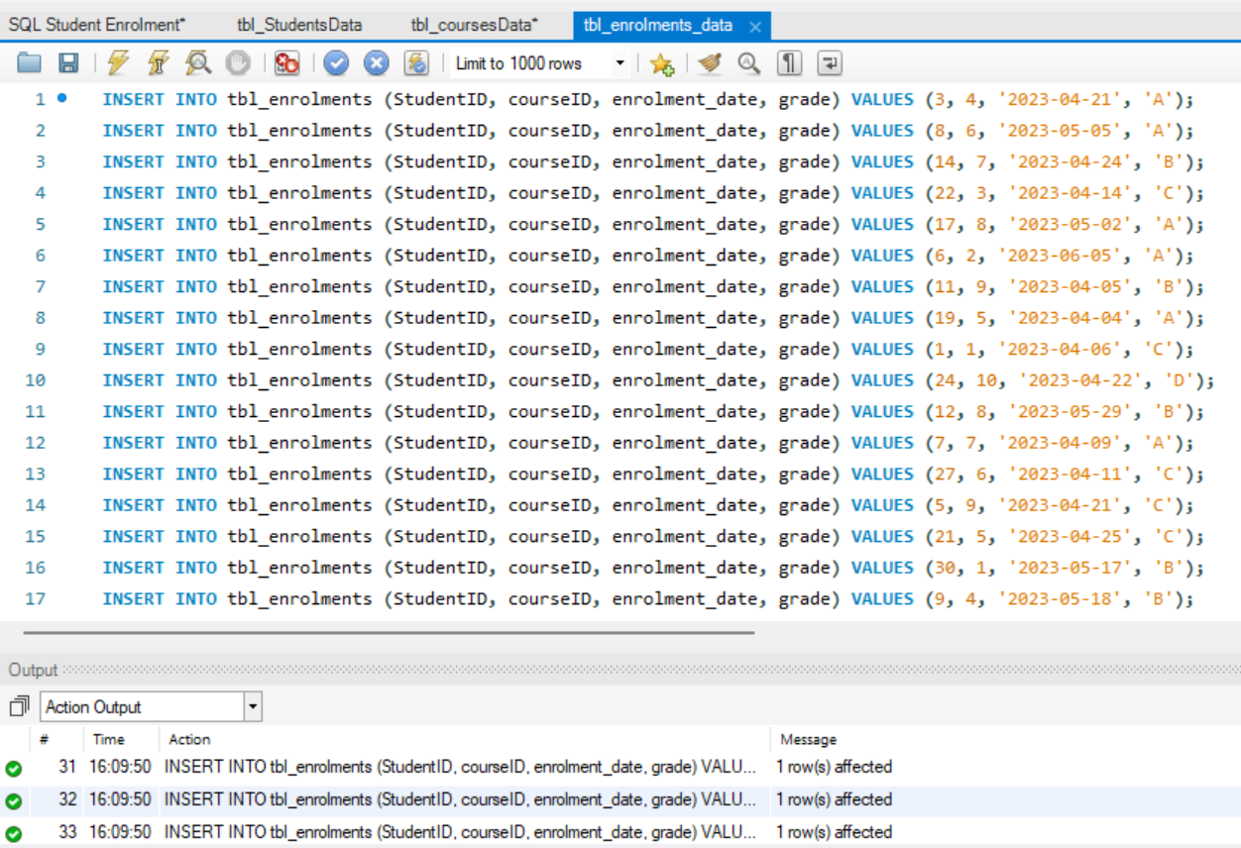

1. **Create queries to list all students, all courses, and all enrolments.**

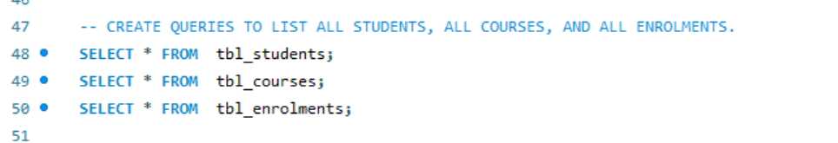

1. **Update a student's grade for a course.**

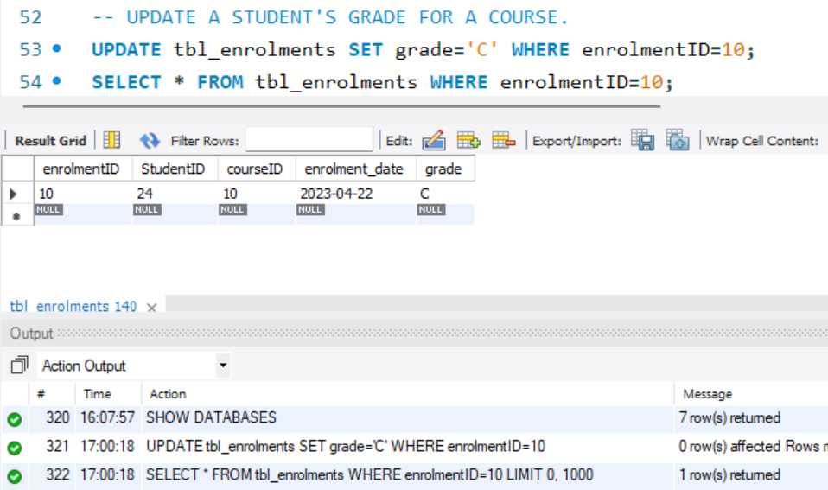

1. **Create views to show students' courses and their grades.**

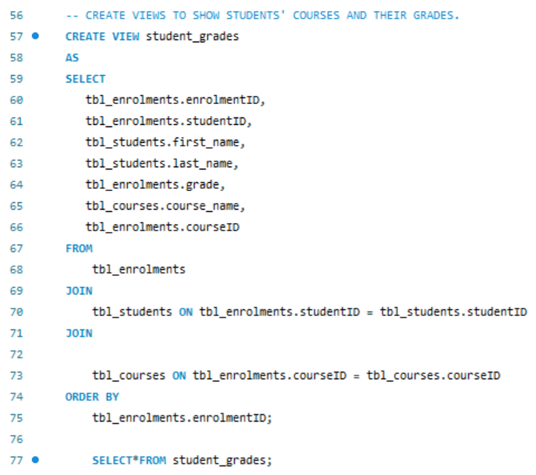

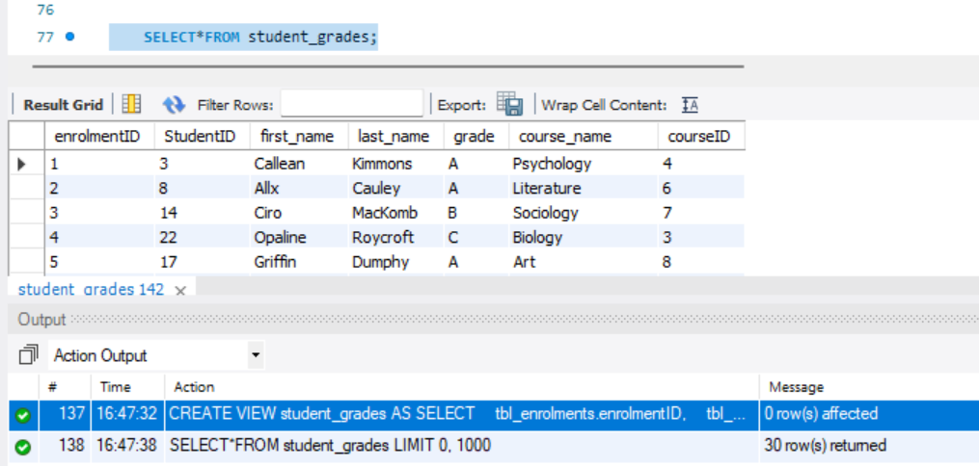

1. **Use stored procedures to enrol a student in a course and handle all related updates.**

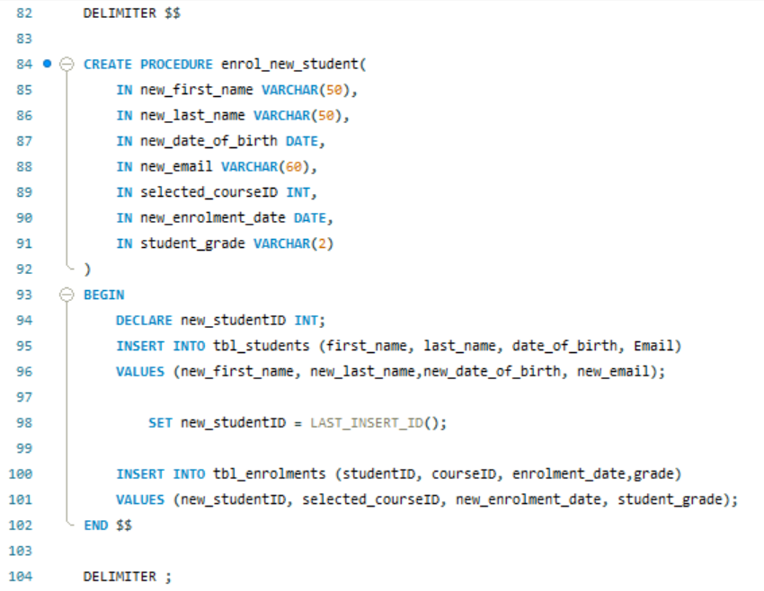

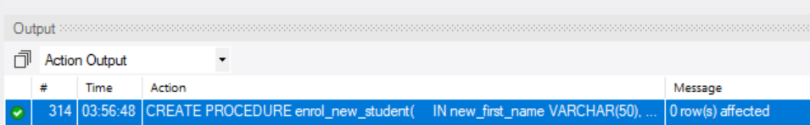

Example of procedure working correctly:

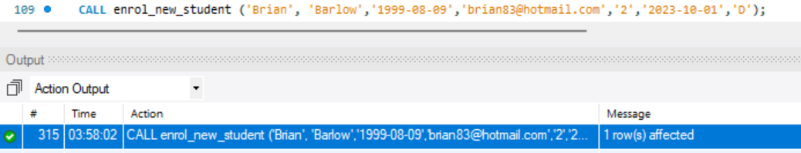

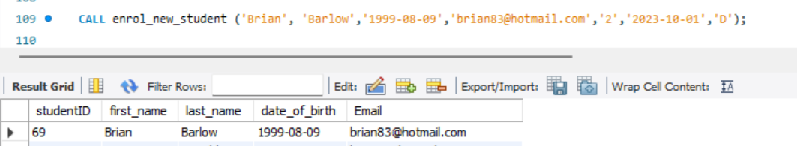



1. **Implement the CASE statement to categorise students based on their grades.**

